PICOS

Description:

PICOS stands for Population, Intervention, Control, Outcomes, and Study Design. In the study "Using GPT-3.5 Turbo Models for Title and Abstract Screening in Systematic Reviews and Meta-analyses", the PICOS framework was utilized to develop a generic prompt framework to instruct the GPT-3.5 Turbo model in performing title and abstract screening for systematic reviews. The researchers utilized the PICOS framework to enhance the efficiency and accuracy of the GPT-3.5 Turbo model in screening citations. This paper first evaluated the PICOS framework used in the study "Using GPT-3.5 Turbo Models for Title and Abstract Screening in Systematic Reviews and Meta-analyses", modified and reproduced the PICOS framework, and finally analyzed the limitations of PICOS framework.

The logical reason for employing the PICOS framework stems from the necessity to mimic the human process of systematic review screening. By structuring the task into the specific elements of PICOS, researchers aimed to enhance the model's ability to make accurate screening decisions. This approach ensures that the model can systematically and comprehensively evaluate each citation based on defined criteria, which is crucial for maintaining the rigor and reliability of systematic reviews. The PICOS framework also allows for the breakdown of complex screening tasks into simpler, manageable components, facilitating the fine-tuning of the model's performance and making the process more transparent and reproducible.

The generic prompt framework in the study "Using GPT-3.5 Turbo Models for Title and Abstract Screening in Systematic Reviews and Meta-analyses" was initially developed and tested using 20% of citations from one systematic review on the efficacy of primary treatment of confirmed COVID-19 in outpatient settings. The researchers conducted iterative testing to refine the prompts. This involved running the model with the prompts on a sample of citations, comparing the model's output with human decisions, and modifying the prompts based on discrepancies. To ensure that the model's output could be easily transformed into "include," "exclude," or "unsure" recommendations, the researchers found that instructing the model to use specific words (e.g., "EXCLUDE," "INCLUDE," "UNKNOWN") was more reliable than asking for binary "YES" or "NO" responses. The prompts were manually fine-tuned for each of the systematic reviews by adapting the generic framework to the specific inclusion and exclusion criteria of each review, and repeating the iterative testing. This fine-tuning used 10% to 20% of citations from each review, selected at random, to identify and address issues such as non-explicit eligibility criteria or specialized knowledge gaps between humans and a machine. For example, specifying the objective of performing a systematic review and using specific phrases improved the model's performance. In the review on the effects of dairy intake on intermediate disease markers in adults, the model initially included animal studies due to the non-specific inclusion criteria referring to "adults without chronic conditions." The fine-tuning process addressed this by clarifying that the subjects had to be human adults.

As a result, the final generic prompt framework in the study "Using GPT-3.5 Turbo Models for Title and Abstract Screening in Systematic Reviews and Meta-analyses" consisted of five prompts, each evaluating a different element of the PICOS framework and providing a recommendation of “include,” “exclude,” or “unsure” for the given citation based on the specific PICOS element under consideration. The output of the GPT models, which included recommendations for each PICOS element of a given citation, was consolidated into a single recommendation to either “include” or “exclude” the citation for full-text screening (Figure 1). Two decision rules were combined to include citations for full-text screening in their study. The first rule, “balanced rule”, considers citations with 0 or 1 “EXCLUDE” in PICOS elements for full-text assessment. This rule aimed to balance sensitivity and specificity, providing recommendations that could help reviewers manage uncertainties or verify their choices during the screening process. The second rule, “sensitive rule”, considers citations with 0, 1, or 2 “EXCLUDES” in PICOS elements for full-text assessment. This rule aimed to maximize sensitivity, potentially reducing the number of citations requiring manual screening by humans.

(Reference: Using GPT-3.5 Turbo Models for Title and Abstract Screening in Systematic Reviews and Meta-analyses)
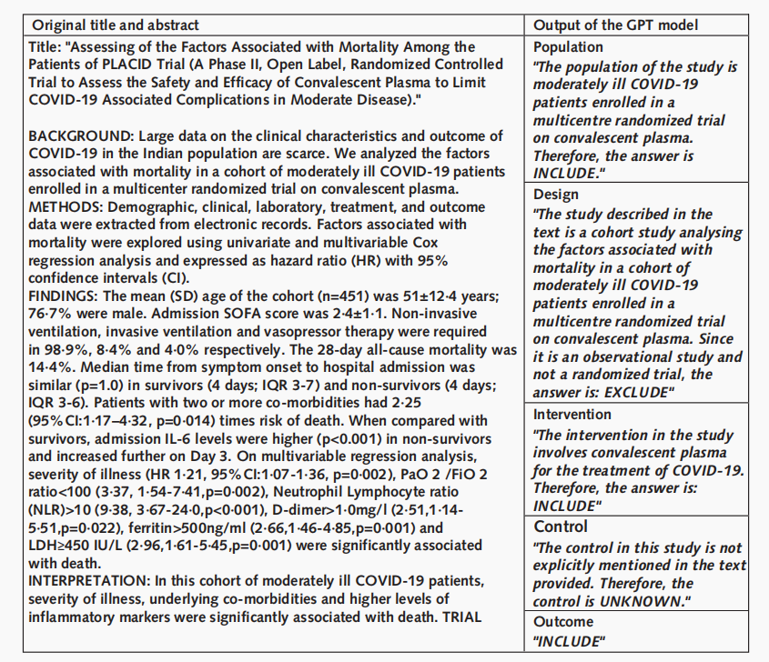
Figure 1. Example of the output of our generic prompt framework for GPT-3.5 Turbo for a given title and abstract.

The result of the study "Using GPT-3.5 Turbo Models for Title and Abstract Screening in Systematic Reviews and Meta-analyses" manifested that, under the balanced rule, the sensitivity of GPT-3.5 Turbo models ranged from 81.1% to 96.5%, while specificity ranged from 25.8% to 80.4%. Across all reviews, GPT identified 7 out of 708 citations (1%) missed by human reviewers that should have been included after full-text screening. This identification came at the cost of 10,279 out of 22,665 false-positive recommendations (45.3%) that would require reconciliation during the screening process. Under the sensitive rule, sensitivities ranged from 94.6% to 99.8%, with specificities ranging from 2.2% to 46.6%. Limiting manual screening to citations not excluded by GPT could reduce the number of citations requiring human review from 127 out of 6,334 (2%) to 1,851 out of 4,077 (45.4%), at the cost of missing 0 to 1 out of 26 citations (3.8%) at the full-text level.

Example:

Generic prompt framework in the study "Using GPT-3.5 Turbo Models for Title and Abstract Screening in Systematic Reviews and Meta-analyses" followed the template for each PICOS element:

"I’m performing a systematic review. I am reading abstracts of clinical studies to assess whether or not they should be included in my review. Assess the study [population, design, intervention, control, outcome] and answer using the following algorithm:
1-If the study includes [write inclusion criteria, create one element per criteria], your answer should contain the word
\"INCLUDE\" (in capital letters).
…
XX-If the study includes [write exclusion criteria, create one element per criteria], your answer should contain the word
\"EXCLUDE\" (in capital letters).
…
XX-If unclear, your answer should contain the word \"UNKNOWN\" (in capital letters)."

Referencing the generic prompt framework, this paper followed the iterative testing steps, reused the PICOS framework, and reproduced the citation screening using GPT-3.5 Turbo model. Inclusion and exclusion criteria for each systematic review were generated using GPT, by providing the following prompt:

"I'm applying PICOS (Population, Intervention, Control, Outcomes and Study design) framework to perform title and abstract screening of articles. For each element of PICOS framework, I need an \"INCLUDE\" (or \"EXCLUDE\") criteria to decide whether a given article should be included in my systematic review of clinical studies of: [title of target meta analysis].
Now based on citations (title and abstract) of the meta analysis, provide me with \"INCLUDE\" (or \"EXCLUDE\") criterion in short sentences."

Applying the criterion suggested by GPT to the generic prompt framework, we successfully reproduced the citation screening process (Supplement table 1).

Problem:

As discussed in the study "Using GPT-3.5 Turbo Models for Title and Abstract Screening in Systematic Reviews and Meta-analyses", limitations of using PICOS framework are the time needed to fine-tune prompt, and GPT performance sensitive to prompt development. This paper stressed the other concomitant and non-negligible problem of utilizing PICOS framework: a high false-positive rate. Under generic prompt framework, results conducted by both the study and this paper manifested that false-positive rate can reach up to 45% with false-negative rate close to 1%. These statistics indicate PICOS framework effectively decreasing manual labor by 55% with nearly perfect false-negative rate. Whereas, conducting a single systematic review was estimated to require over 1,000 hours of highly skilled manual labor, with the time required varying in proportion to the volume of evidence to be screened. Despite the notable reduction in manual labor, this performance, 45% false-positive rate, equivalent to over 450 hours of manual labor, remains significantly higher than the acceptable false-positive rate suggested by the target group of this paper. Thus, more precise selection of citations for full-text screening is needed on top of PICOS framework.

Supplement Table 1: Final prompt for a systematic review on “Evaluation of influenza drugs used to prevent hospitalization and improve treatment effect in patients with influenza”

“I’m performing a systematic review. I am reading abstracts of clinical studies to assess whether or not they should be included in my review. Assess the population and answer using the following algorithm:
If the study includes patients diagnosed with influenza, your answer should contain the word \"INCLUDE\" (in capital letters).
If the study includes patients at risk for hospitalization due to influenza, your answer should contain the word \"INCLUDE\" (in capital letters).
If the study includes patients with non-influenza respiratory infections, your answer should contain the word \"EXCLUDE\" (in capital letters).
If the study includes healthy volunteers without influenza symptoms, your answer should contain the word \"EXCLUDE\" (in capital letters).
If it the population is unclear, your answer should contain the word \"UNKNOWN\" (in capital letters).”

“I’m performing a systematic review. I am reading abstracts of clinical studies to assess whether or not they should be included in my review. Assess the study type (also called study design) and answer using the following algorithm:
If the study is a randomized controlled trial, your answer should contain the word \"INCLUDE\" (in capital letters).
If the study is a meta-analysis of clinical studies, your answer should contain the word \"INCLUDE\" (in capital letters).
If the study is a case report or case series without comparison group, your answer should contain the word \"EXCLUDE\" (in capital letters).
If the study is a commentary or review without original data analysis, your answer should contain the word \"EXCLUDE\" (in capital letters).
If it the study type is unclear, your answer should contain the word \"UNKNOWN\" (in capital letters).”

“I’m performing a systematic review. I am reading abstracts of clinical studies to assess whether or not they should be included in my review. Assess the treatment and answer using the following algorithm:
If the study has a use of influenza drugs for prevention or treatment, your answer should contain the word \"INCLUDE\" (in capital letters).
If the treatment has non-pharmacological interventions for influenza prevention or treatment, your answer should contain the word \"EXCLUDE\" (in capital letters).
If the study is evaluating vaccine effectiveness without drug intervention, your answer should contain the word \"EXCLUDE\" (in capital letters).
If it the treatment is unclear, your answer should contain the word \"UNKNOWN\" (in capital letters).”

“I’m performing a systematic review. I am reading abstracts of clinical studies to assess whether or not they should be included in my review. Assess the control and answer using the following algorithm:
If the study’s comparison group receiving standard care or placebo, your answer should contain the word \"INCLUDE\" (in capital letters).
If the control are placebo-controlled trials with no active drug intervention, your answer should contain the word \"EXCLUDE\" (in capital letters).
If the control compares different drugs without a control group receiving standard of care, your answer should contain the word \"EXCLUDE\" (in capital letters).
If it the control is unclear, your answer should contain the word \"UNKNOWN\" (in capital letters).”

“I’m performing a systematic review. I am reading abstracts of clinical studies to assess whether or not they should be included in my review. Assess the study outcomes and answer using the following algorithm:
If the following outcomes has been collected: Improvement in hospitalization rates, Efficacy of influenza drugs in treatment, your answer should contain the word \"INCLUDE\" (in capital letters).
If the outcomes are related to cost-effectiveness or pharmacokinetics only, your answer should contain the word \"EXCLUDE\" (in capital letters).
If the outcomes are not directly related to hospitalization or treatment effect in influenza patients, your answer should contain the word \"EXCLUDE\" (in capital letters).
If it the study outcomes are unclear, your answer should contain the word \"UNKNOWN\" (in capital letters).”

